Project 2

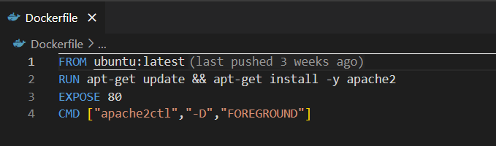
- FROM baseImage – specifies the base image used to build a docker image
- RUN command parameter – The Run command executes a shell command inside the docker container during the build process. In this case it updates the package and installs the apache2 package using the apt-get package manager
- EXPOSE port – The docker container listens to the specified port. Here we use 80, which is the default port of the apache web server.
- CMD[‘”executable”, “parameter”] – This command specifies the default command to run when the docker container starts. Here we use the apache2ctl command with the -D foreground option. It starts the apache web server in the foreground and allows the container to run as a main process. It ensures the container doesn’t stop randomly.

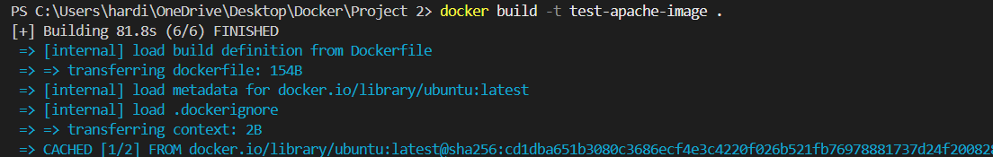
- We open a new terminal
- The docker build commands builds the image.

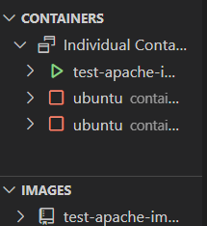

- This command creates a new container which runs the image that we created. -p publishes a container’s port to the host
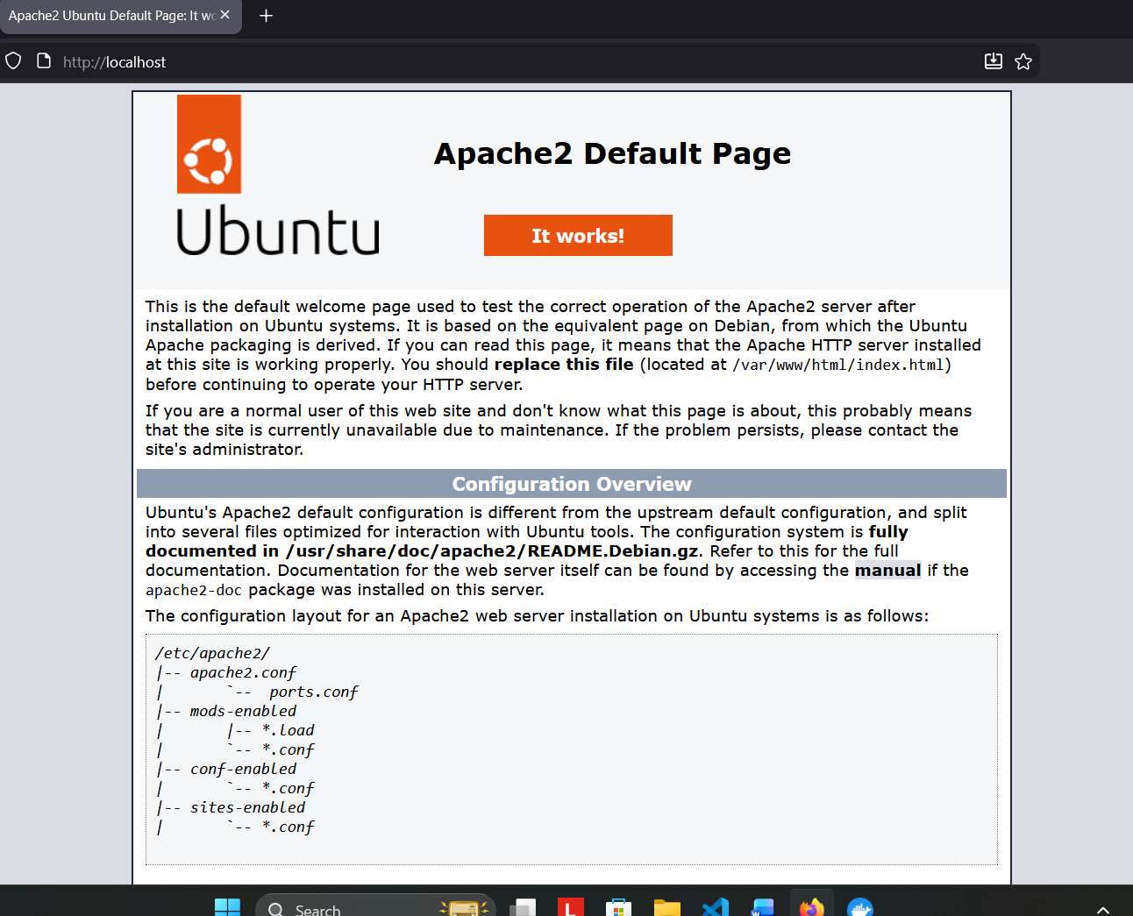
- Finally we run the localhost on our web browser. It leads us to the apaceh2 default page.

